IT-2030

David Hudson

Lab 9

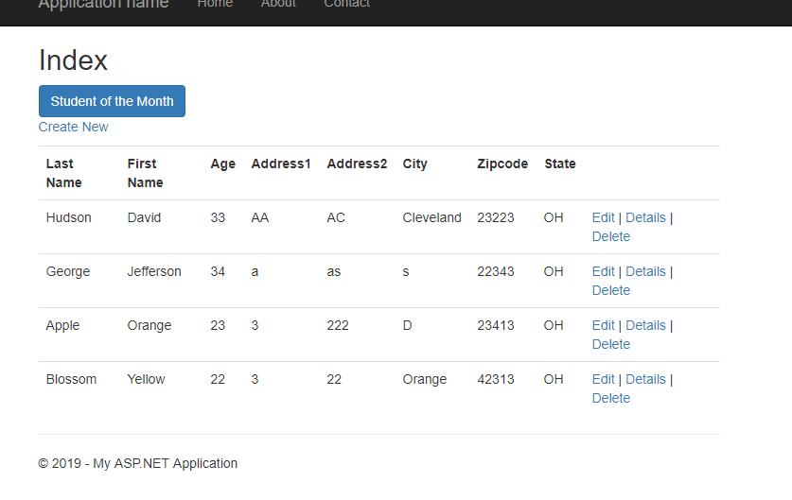

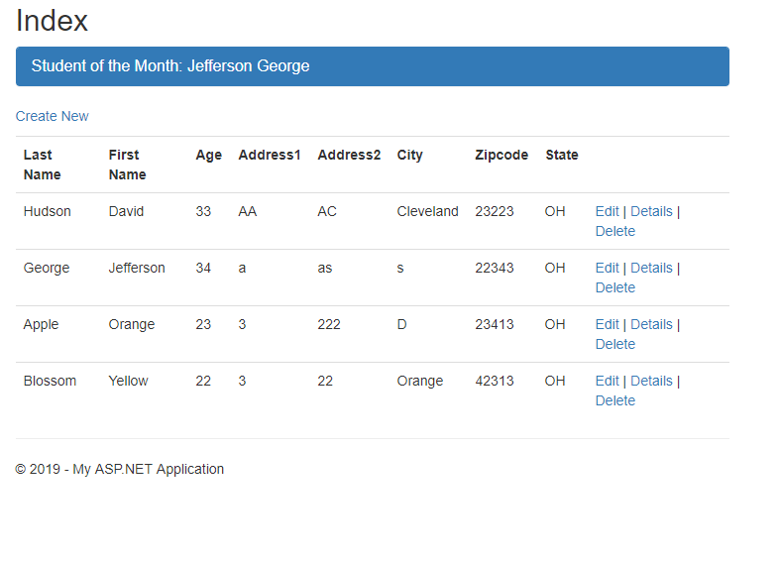

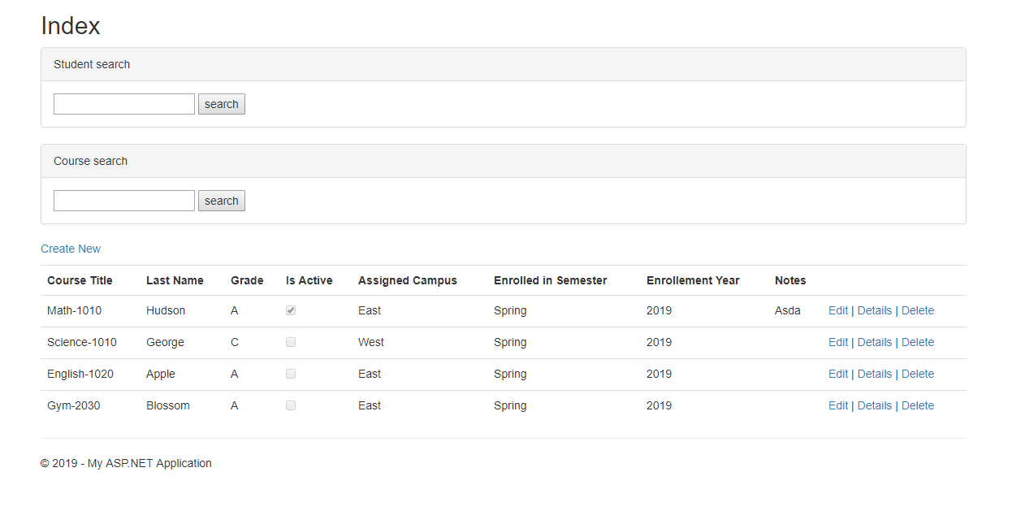

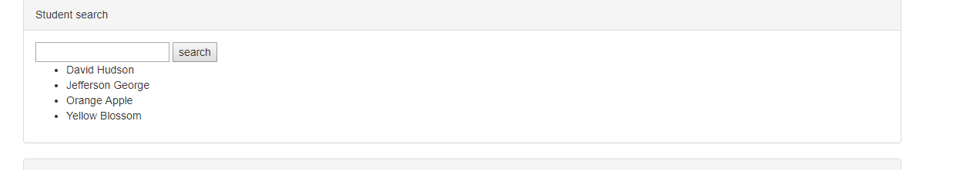

Nothing shows up when I search by course, I tried to walk through the steps and look at the console but no errors appear. I am not entirely sure where I went wrong. I attempted to change things around to see where the error was but was unable to figure out the issue that it was receiving. I did notice that it mentions that 0 results are found from my search but I even tried to switch my search up multiple ways to attempt to have it return any results but had no luck.